Spam Email Classification Report

1. Problem Description
This project addresses a binary text classification problem with the objective of classifying emails into:
- Class 0: Non-spam (legitimate emails)
- Class 1: Spam emails
The task is formulated as a supervised learning problem, using TF-IDF vectorization for text representation and Logistic Regression as the classification model.

2. Dataset Analysis

2.1. Dataset Overview
The dataset contains 5,171 email samples, with the following class distribution:
- Non-spam (Class 0): 3672 samples (~71%)
- Spam (Class 1): 1499 samples (~29%)
This indicates a moderately imbalanced dataset, which must be considered when selecting evaluation metrics and training strategies.
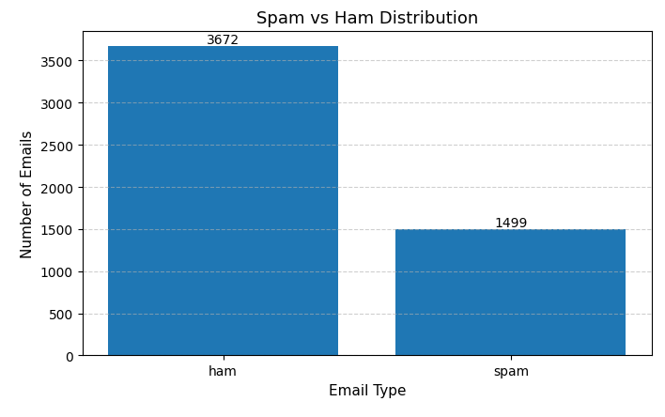

.2. Identified Dataset Issues

(1) Class Imbalance
The dataset contains significantly more non-spam emails than spam emails. Without mitigation, the model may become biased toward predicting the majority class, leading to poor spam detection performance.

(2) Text Noise and Inconsistency
Raw email text includes:
- Uppercase and lowercase inconsistencies
- Special characters and digits
- Irrelevant tokens
These factors increase feature sparsity and reduce model effectiveness.

(3) Short and Sparse Text Data
Emails are often short, and single-word features may be insufficient to capture spam-related semantics.

3. Data Preprocessing and Mitigation Strategies

3.1. Text Cleaning
The following preprocessing steps were applied:
- Conversion to lowercase
- Removal of non-alphabetic characters
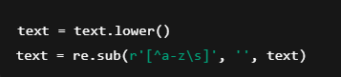

3.2. Text Vectorization with TF-IDF
Text data was transformed using TF-IDF Vectorization with the following configuration:
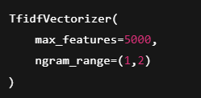

4. Evaluation Metric Selection

4.1. Limitations of Accuracy
The model achieved a high accuracy of 98.07%, but accuracy alone is insufficient for imbalanced datasets, as it does not reflect performance on minority classes.

4.2. Priority Evaluation Metrics
For spam detection, the following metrics are prioritized:
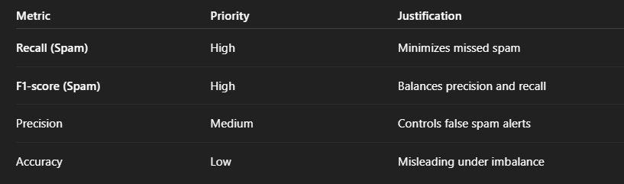
Primary focus: Recall and F1-score for the spam class (Class 1).

5. Model Performance Evaluation

5.1. Overall Performance
- Accuracy: 98.07%
- Macro-average F1-score: 0.98
- Weighted-average F1-score: 0.98
These results indicate strong and stable overall performance.

5.2. Class-wise Performance Analysis

🔹 Non-spam (Class 0)
Metric |  |  |  |  |  |  |  |  |  |  |  |  |  |  |  |  | Score
Precision |  |  |  |  |  |  |  |  |  |  |  |  |  |  |  |  | 0.99
Recall |  |  |  |  |  |  |  |  |  |  |  |  |  |  |  |  | 0.98
F1-score |  |  |  |  |  |  |  |  |  |  |  |  |  |  |  |  | 0.99
The model reliably classifies legitimate emails with very low false-positive rates.

🔹 Spam (Class 1 – Critical Class)
Metric |  |  |  |  |  |  |  |  |  |  |  |  |  |  |  | Score
Precision |  |  |  |  |  |  |  |  |  |  |  |  |  |  |  | 0.95
Recall |  |  |  |  |  |  |  |  |  |  |  |  |  |  |  | 0.99
F1-score |  |  |  |  |  |  |  |  |  |  |  |  |  |  |  | 0.97
The model successfully detects 99% of spam emails, resulting in minimal false negatives. A small number of false positives is acceptable in spam detection systems.

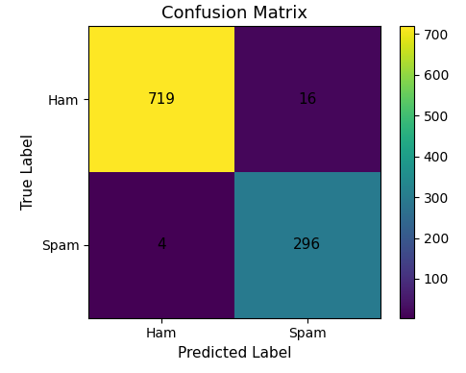
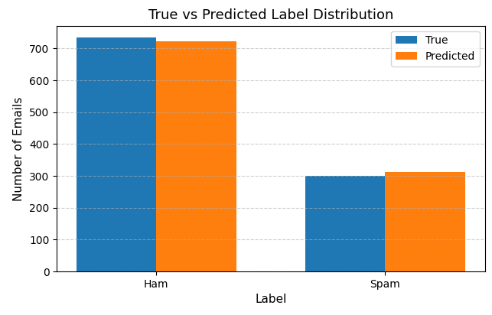

7. Conclusion
- The dataset exhibits moderate class imbalance, text noise, and limited size
- Effective preprocessing and TF-IDF bigram features significantly improved data quality
- Logistic Regression with class weighting achieved:
  - High spam recall (0.99)
  - Stable F1-score (0.97–0.98)
- The model meets practical requirements for real-world spam email detection
This model serves as a strong baseline and is suitable for further improvements such as:
- Cross-validation
- Model comparison (Naive Bayes, Linear SVM)
- Deployment in production or API-based systems

